 | Working with Funders Questionnaire | 
On this form we ask if you would like to give views as well as answer questions directly. | 
We will read anything you write from a few words or sentences to much more. We have not put any limits on the amount of words you can use. It really is up to you how much you choose to write about a question, if you choose to write anything at all. | 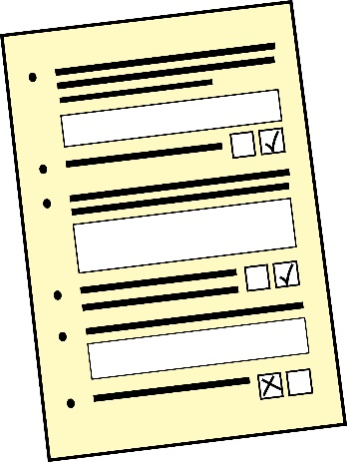
One of the reasons we have done this is because it is often difficult to write something to a word count. We know the editing can take a long time. | 
Please feel free to answer questions with a video or voice recording if you prefer. | 
Also, if you’d rather talk face to face with us or over Zoom to answer any or all of the questions we are happy to do that. | 
If you contact us through our email we will do our best to arrange a meeting with you. | 
We are also happy to talk with you over the phone if you want to call us. | 
We will keep anything you share with us anonymous. | 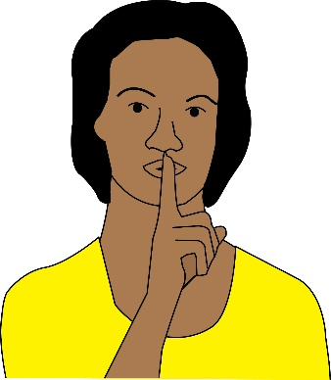
If you have any questions or want to contact us about the questionnaire please email us at  bobteam@breakingoutofthebubble.org.uk  or call us on 07483 439607 |   

- From the following list how would you describe your organisation as (please tick)

Residential care home | 
Support for independent living | 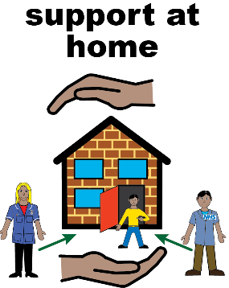
Educational service such as a college | 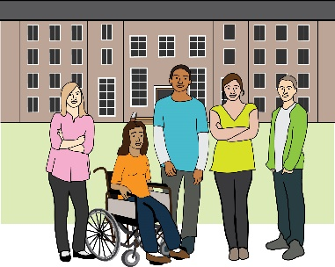
Employment skills training service | 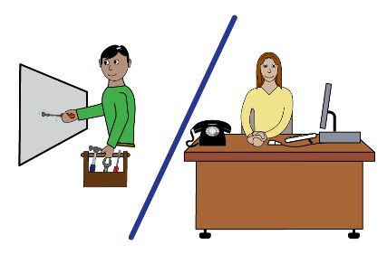
Self-advocacy organisation | 
Deaf or disabled persons’ organisation | 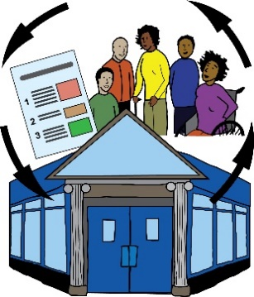
Other - if other can you say what sort of organisation you are

- Can you tell us if you are funded by any of the following (please tick) |  | 
Trusts | 
Hospitals | 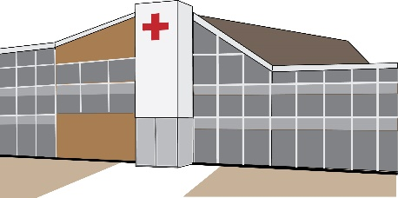
Universities | 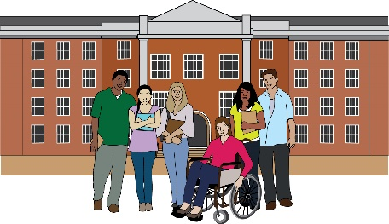
Government including local councils | 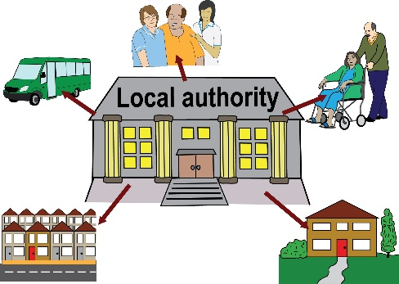
Health or social services | 
Other - if other can you say what sort of organisation funds you

- Have you had any trouble with funders not getting back to you or not communicating with you from the following list? (please tick)

We can’t reach funders by phone |   
When we phone funders they don’t always get back | 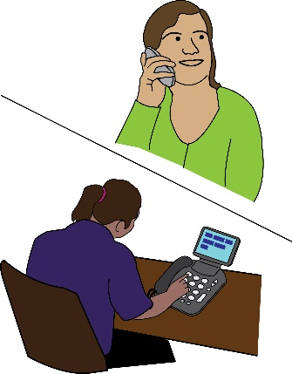  
Funders don’t always reply to our emails or take a very long time | 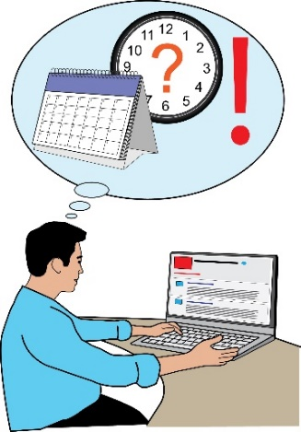
Funders won’t come to meet us before we send in an application | 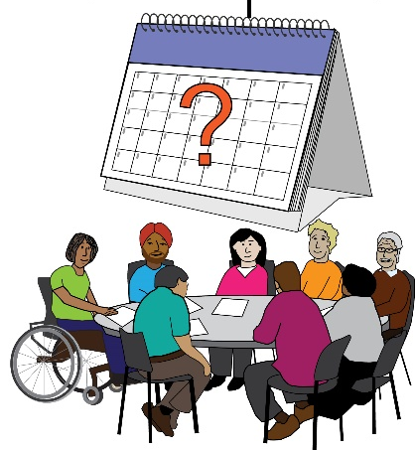
Funders won’t meet us after we have received the funding | 

- Are funders friendly with you? |  | 
Yes   | No | Can’t say because we don’t see them

If you ticked yes or no could you explain why you did? | 

- Would you find it useful if funders met with your organisation face to face during the application process and while working together? |  | 
Yes | No

If you ticked yes or no could you explain why you did?

- Do you have trouble filling out application forms? |  | 
Yes | No

If you ticked yes or no could you explain why you did?

- Do you think application forms should be more accessible for people with learning difficulties? |  | 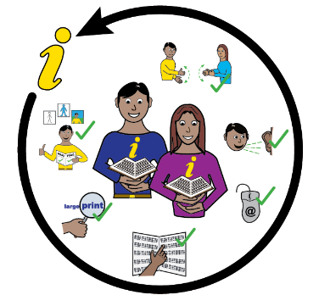
Yes | No

- How involved are PWLD involved in developing and writing your funding applications (please tick) | 
Completely involved in all parts of the application

Involved quite a lot

Involved a bit

Not involved at all

Could you please explain why you ticked the answer you did?

- Do you think easy read applications are a good idea? |  | 
Yes | No

Could you explain why you answered yes or no?

- Do you think having the option to make video applications is a good idea? |  | 
Yes | No

Could you explain why you ticked yes or no?

- Would you like online funding processes to be easier to fill in, more user friendly |  | 
Yes | No

Could you explain why you ticked yes or no?

- Would you like a wider range of funds to be available which would offer more opportunities for different work? |  | 
Yes | No

Could you explain why you ticked yes or no?

- Do you feel like you have much power and control when working with funders? |  | 
Yes | No

Could you explain why you ticked yes or no

- Could you explain who you think has the power and control in funding applications and why do you think this? | 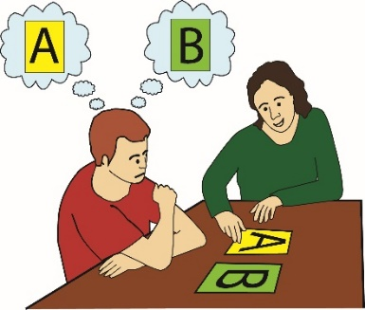  

- Do you feel like you are often in competition with other organisations? |  | 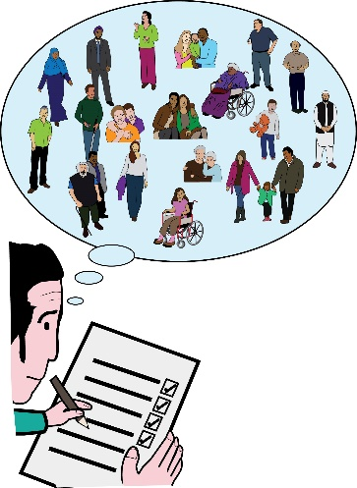
Yes | No

Could you explain why you ticked yes or no?

- Do you think funders need Learning Difficulty awareness training? |  | 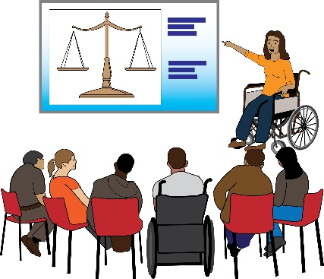
Yes | No

Could you explain why you ticked yes or no?

- What would you like to see change when working with funders? | 

- If you have anything else you would like to say about what would make applying for funds better for you that you have not mentioned so far please feel free to let us know? | 

- Have you had some good experiences with funders? |  | 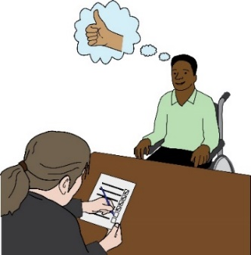
Yes | No

If you have had good experiences that have not been mentioned so far could you tell us about them.

- Have you had some bad experiences with funders that have not been covered already in this questionnaire? |  | 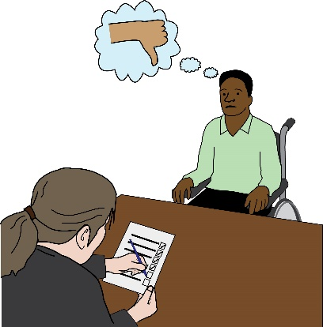
Yes | No

If you ticked yes could you tell us about these experiences?

- What would make funding applications more accessible for you and your organisation? | 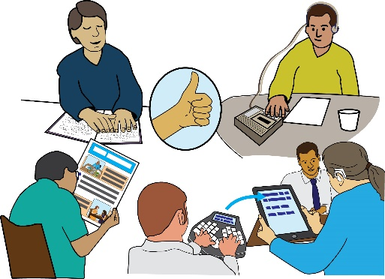

- Did you answer this questionnaire as (Please tick where you fit best) |  | 
A group… | 
A group of people with learning difficulties | A group of people without learning difficulties
An individual… | 
An individual with learning difficulties | An individual without learning difficulties

- Could you explain how you worked to fill in this form? | 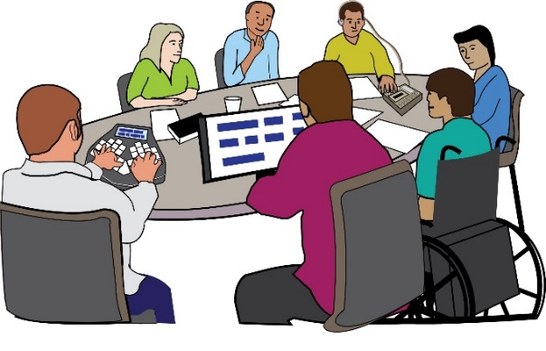

If you have any questions or want to contact us about the questionnaire please email us at
bobteam@breakingoutofthebubble.org.uk

or call us on 07483 439607

